Literature Searching: Finding What you Need Accessibility Write Up
Contents
Literature Searching: Finding What you Need Accessibility Write Up 1
Session Structure 1
Section 1: Planning your Literature Search 1
Practical Activity 1 4
Section 2: Doing your Literature Search 4
Searching using Google Scholar 5
Searching using iDiscover 7
Searching using Databases 8
Searching on the Web 9
Practical Activity 2 10
When to Stop Searching 10
Section 3: Next Steps for your Literature Search 10
Keeping Up To Date 10
Addressing Gaps 10
Bias 11
Making Connections between Sources 11
Practical Activity 3 11
Summary of Key Points from the Session 12

Session Structure
This session is run by the Technology Library Team. If you would like to contact us about anything from this session please feel free to do so via our email techlib@lib.cam.ac.uk.
The aim of this session is to give you some helpful hints and tips on how to plan, do and the next steps for your literature search. It doesn’t matter if you have never done a literature search before or if they are a key part of your work, this session has something for everyone.

Section 1: Planning your Literature Search
Like a lot of things in life, good planning of your literature search can make the process of doing your search a lot more effective and efficient.
A literature search is a task that you HAVE to do as part of your studies. It’s unavoidable! It might seem like a lot of work but searching academic literature can have many benefits.
Such as:
- Helping to refine the scope of your work/research.
- Enabling you to explore similar and related topics.
- A way to assess the current knowledge in your field.
- You can find out what knowledge is currently unknown.
- Explains your research in context.
You should start planning your literature search as soon as possible after you receive your question and/or decide on your research area. The sooner you start planning the better. It might seem like a waste of time to do these things before you actually start searching but trust us it will save you time and effort when it comes to doing your search and writing up your work.
First, let’s look at a topic which sometimes causes some confusion. What is a literature search and what is a literature review? Are they the same thing? Which one am I supposed to be doing?
They are different!!
A literature search to a process you go through to enable you to write your work. It is the process of searching for information. You do this in not just one search, but many. You make notes on the information you find and that informs the work that you later write. A literature search can either be formal or informally structured, it depends on what works for you, how you work best and what you may have been asked to do by your department.
A literature review is a dedicated piece of work which is separate to an essay or report. It is a survey of the relevant literature on a given subject area. To complete this survey, you will have performed a literature search. In a review you would connect and summarise that information and present a critical analysis of the current research of the field. The review would also be presented in a standardised and organised way.
Now that you understand whether you are doing a literature search, or a literature review you can begin the steps to planning your literature search.
Set up a Search Strategy. You might ask what is a search strategy? Simply, it is a set of processes/an approach you are going to use to complete your search. The strategy is 5 simple steps. It is not there to overcomplicate your search or take you lots of extra time.
We are going to demonstrate this process by planning a search on automation in beer production.
Step 1 -This includes checking that you understand what you are searching for and why.
Step 2 – Begin scoping out your subject area/research question to identify key words, phrases, and questions which you may use to lead your search. Some people may find it helpful to do this using a mind map.
This is the scope of the topic automation in beer production.
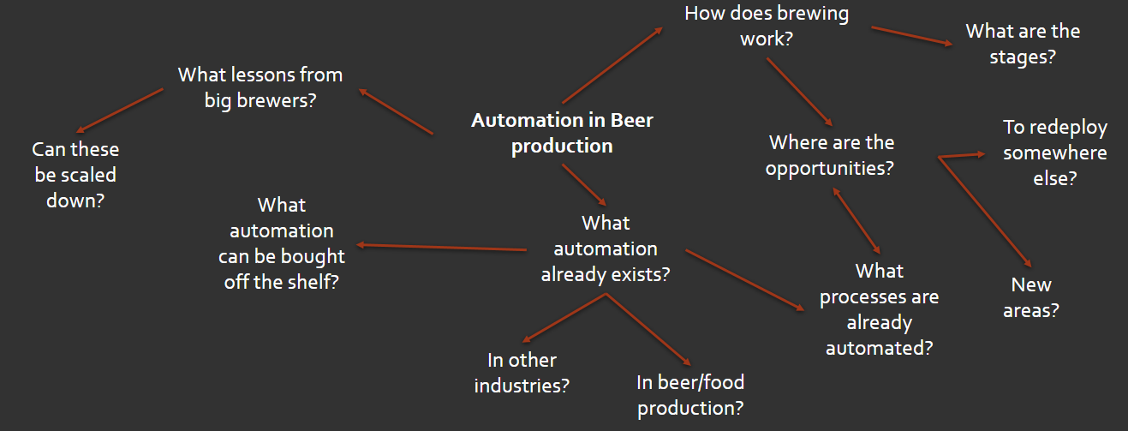
Key words identified
- Automation
- Beer
- Production
Step 3 – Next you need to develop the keywords/phrases you have come across.
The better your keywords, phrases and questions the more relevant and refined your search will be which saves you time and effort in the long run.
- Think about synonyms, acronyms, abbreviations, and alternative spellings.
- How you might apply Boolean logic.
- What happens when you type a word or phrase/question in Google or Wikipedia. Important note: use these results to build your search, not in your search.
Applied to example
- Automation – automated/industrialised/industrialzed/mechanisaion/mechanization
- Beer/Ale
- Production/manufacturing/manufacture/ fermentation
Step 4 – Shape your Search. There are three ways in which you can structure your search which are;
- Top-Down Search – Looking for general background and/or reading around the subject.
- Bottom-Up Search: You have a specific term, or research question that you start with and then broaden your search.
- Citation Trail Search – You follow citation links found in a key source. This technique can be used alongside the two above, especially when you find a source that closely aligns to your topic.
Step 5 – Record your search.
It is very important that you record the result of your search as you do it. The more organised your records, the easier it will be to find relevant quotes and/or citation information during your writing process.
If you would like help with referencing, then please feel free to contact the Technology Library team via email for visit us at the Engineering Department or the West Hub.
An online resource that is also very useful is Cite Them Right - Home (citethemrightonline.com).
The things you need to record when searching are;
- When - the date of the search
- Where – which source and where you found it (For example, which database did you use)
- How – the words/phrases/questions, and in what order you used them to produce the search result.
We have a template available which you can use if you would like, or you can make you own. The Search Record template is attached to your pre session email.

Practical Activity 1
Now we are going to give you a generic topic to have a go at steps 2 and 3 in the search planning process. You are going to work as a whole room. You will have 8 mins to do this; after which you will be asked to feedback on what you have done.
Generic Topic – The potential use of artificial intelligence in pizza delivery.
Remember
- Step 2 – Scope out your subject area to identify key words/phrases/questions.
- Step 3 – Develop your keywords/phrases/questions.
Now you have practiced and planned a search you are ready to start DOING your literature search.

Section 2: Doing your Literature Search
When applying your keywords/questions in a search it is important to vary the word order you use and apply Boolean logic as these will impact the nature and type of search results that you get. It is important to record each of the variations you use in your search log/record so you can learn what gives you the best quality results for your search topic.
Automated production beer
Production automation beer
If you don’t know what Boolean Logic is, then don’t worry; it is the logic databases use to give results. They can be very useful as it gives you more control over your search outcome and helps you connect multiple terms/topics together. The three Boolean operators are AND, OR, NOT.
- AND: Will narrow your search results and both terms need to be present. It is sometimes implied by databases when searching.
- OR: Connects terms together for your search producing broader search results.
- NOT: Excludes and narrows your search.
Be mindful of the logical order in which you use words which are connected using Boolean operators. AND nearly always is prioritised over OR and NOT. You can combine AND and OR using brackets, for example;
Search for – automation AND (Beer OR Ale)
Other worked examples that could be applied
Beer production NOT manual
Manufacturing AND automation AND beer
Industrialised OR industrialzed beer production
Once you have decided on the formation of your search term you need to decide where to start searching.
We are going to make an educated guess that Google Scholar is a place that most people start with.

Searching using Google Scholar
Google Scholar indexes academic content both freely available and behind pay walls. Whilst Google Scholar is not the most comprehensive place to search it is a really good place to start. It has added features which enable you to embed links to content available from Cambridge University Libraries within your search (which we show you how to do below). You just need to aware of the limitations of Google Scholar; the search filters are quite limited, and it is unlikely to show unpublished material unless explicitly asked.
How to set up Google Scholar to link to Cambridge University Libraries
Step 1: Check that you are signed into Google. You can use your @cam.ac.uk email address or a personal one.
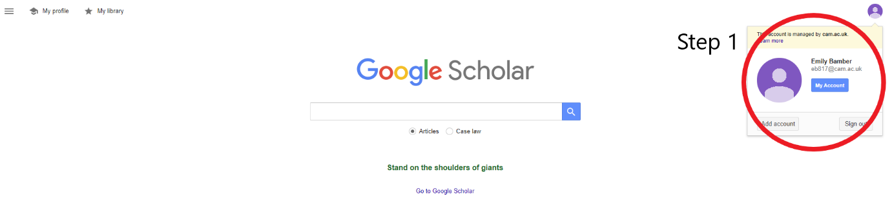
Step 2: Click on the menu bar on the top left-hand side of the window.
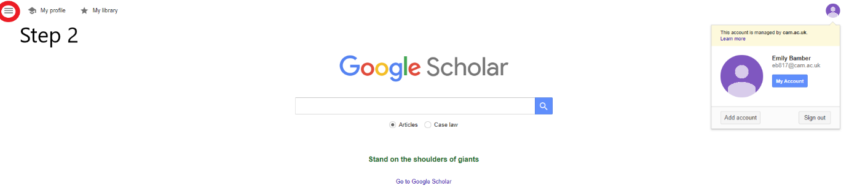

Step 3: Select Settings in the menu bar
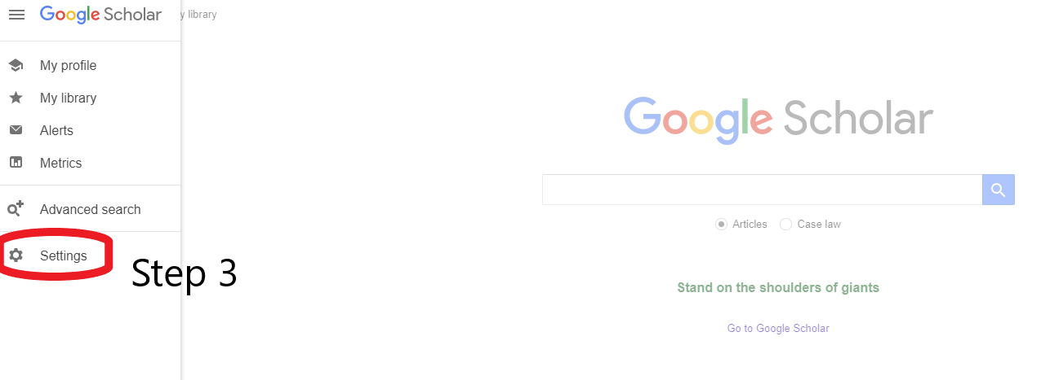
Step 4: Once in Settings, select Library Links.
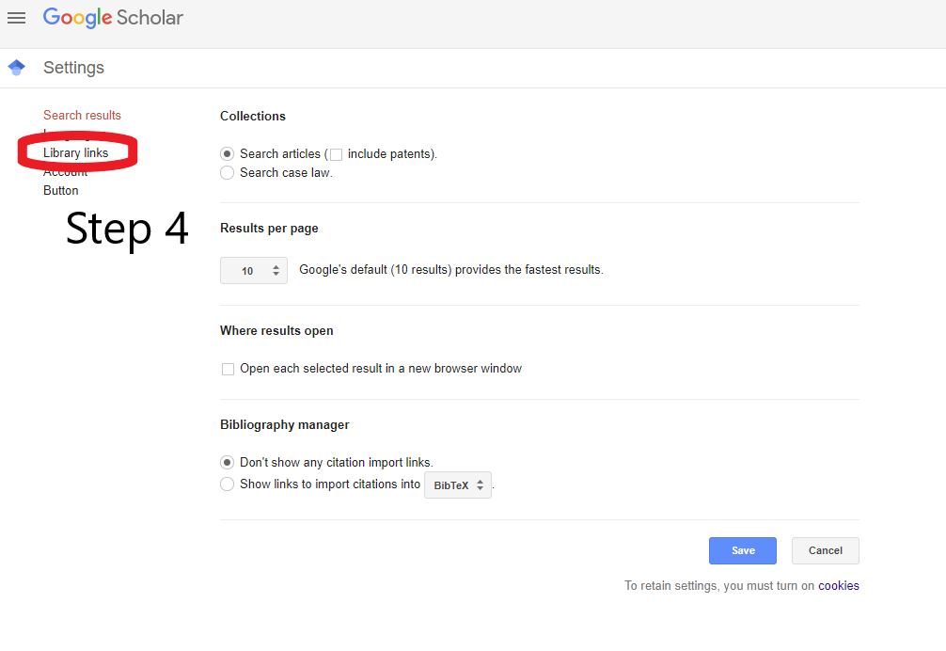
Step 5: Search for University of Cambridge. You need to select ‘University of Cambridge – ejournals@cambridge’ by ticking the box and then selecting the save button. Once you have done this any of your search results that are available via Cambridge University Libraries will be directly linked adjacent to the search results.
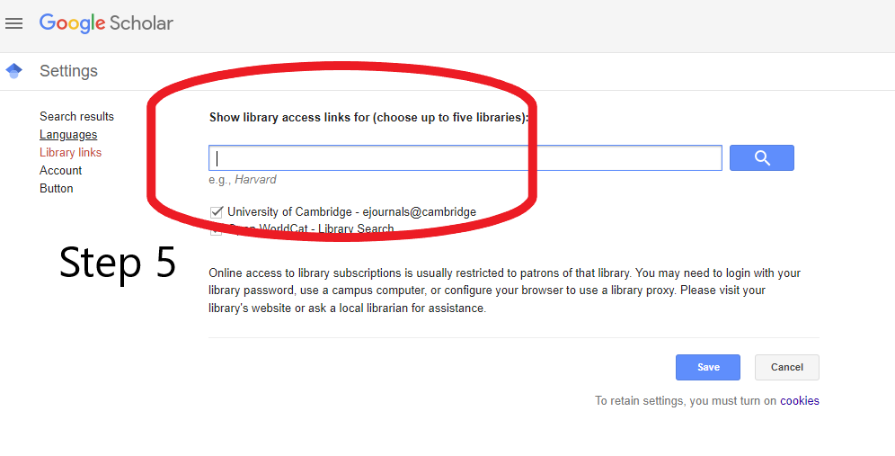
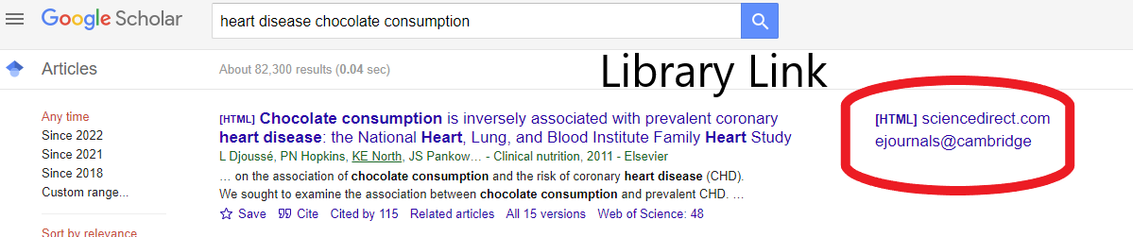
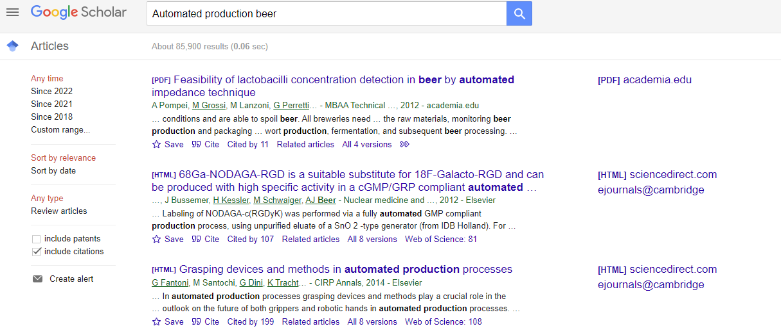
This helpful video Searching Google Scholar - YouTube provides these instructions in video format for those who find that helpful.
----------------------------------------------------------------------

Searching using iDiscover
Next, you may think to search the Cambridge University Libraries online catalogue called iDiscover.
iDiscover (cam.ac.uk)
Here you can search the print and electronic collections of the University Library, all Faculty and Departmental libraries and College libraries.
Anyone can view the Cambridge University Library catalogue but if you would like to request an item or view an item on a database subscribed to by Cambridge University then you will need to log in using your Raven log in.
You can search using the search bar on the front page of iDiscover or you can use the database function which we will explain below.
The central search bar on iDiscover will search the Cambridge University catalogue around parameters which you can set via changing the radio buttons or through ‘Advanced Search’. Results can be filtered between physical items (books), online resources and location (for example your given college library.)



Cambridge Libraries Collection: This option will produce title level book and journal title results.
Articles and online resources: This option will produce journal article and possible book chapter titles that match your search keywords. This is often the best place to start especially when your search area is a STEMM topic.
Search everything: This option will also produce results for content that Cambridge University does not own. The filters are limited via this option, and it can provider a vast number of results that are not particularly relevant to your search area.
If you would like further help with navigating and using iDiscover then follow this link below
Home - iDiscover - LibGuides at University of Cambridge Subject Libraries
Here you will find a collection of short videos taking you through using iDiscover and searching for different types of material.

Searching using Databases
The Database A-Z option takes you to a page where you can search for databases that Cambridge subscribes to via name and subject area. Throughout the course of your studies, you will be familiar with key databases for your subject so this will enable you to reach them efficiently.
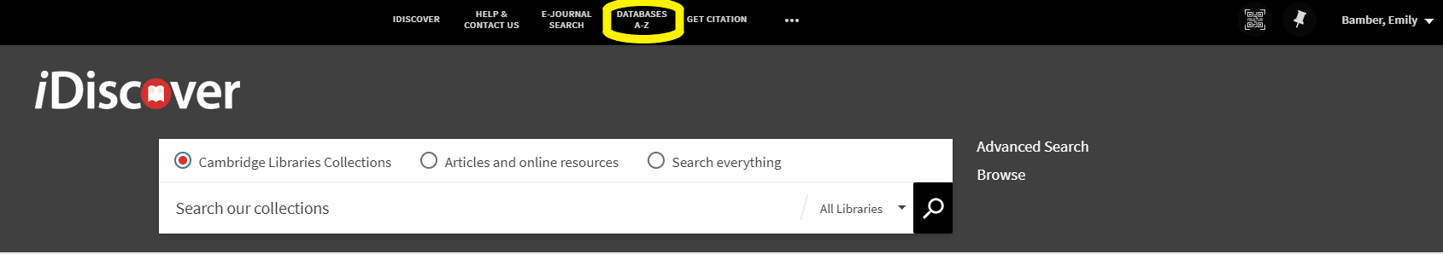
Once in the Database A-Z choose your subject from the drop down menu. (For example: Engineering)
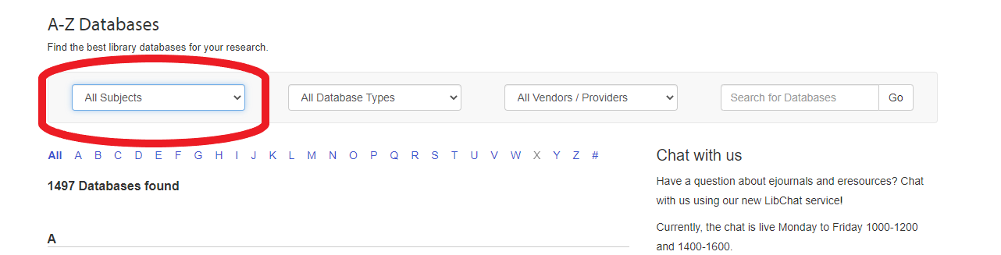
Once you have chosen your subject you will view a page with both ‘Best Bets’, databases that are popular for your subject, and a full A-Z of databases for that given subject.
Each database name takes you directly to the database where you will be able to seach the resource directly. Searching a database directly gives you more control over your search results.
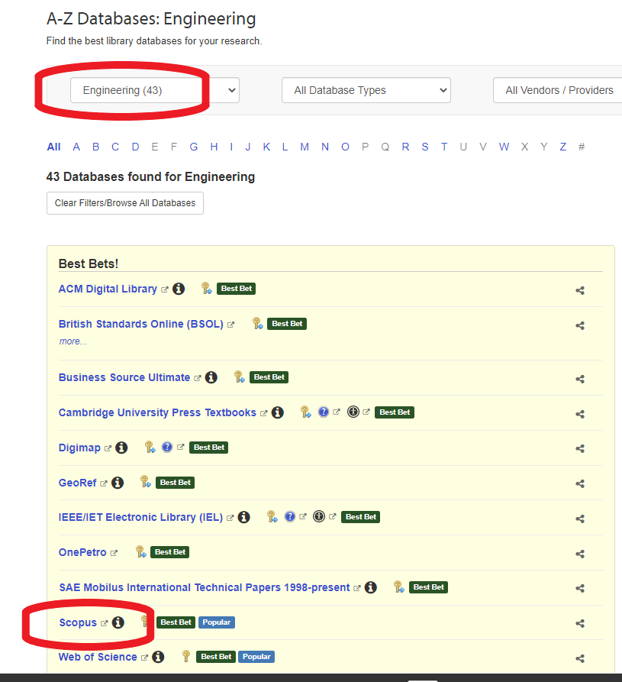

Searching on the Web
Cambridge also subscribes to several browser plug in/extensions that can be beneficial when literature searching, especially when away from Cambridge and/or not on the university network. These are Lean Library and Lib Key Nomad and can be both used simultaneously. They act in a similar way by enabling library links like on your Google Scholar and can save you time and aggravation when searching.
Instructions for how to downland and set up Lean library can be found here- Access full text anywhere | Cambridge Libraries
Instructions to set up and use Lib Key Nomad can be found here - LibKey Nomad | Cambridge Libraries

Practical Activity 2
Now you are going to have a go at doing some literature searching using the generic example that you planned earlier in the session.
Remember to record each of the individual searches that you do. You will have 8 mins to search each of the different locations which we have mentioned above.
- Google Scholar
- iDiscover
- Web of Science (via Database A-Z)
- Scopus (via Database A-Z)

When to Stop Searching
A key part of doing an effective literature search is knowing when to stop searching. Stop too soon and you won’t have enough and/or the right kind of sources to complete your work. Stop too late and you will have too much and you will be overwhelmed and struggle to compile a succinct piece of work.
Indicators to stop searching are;
- You are finding a lot of repetition in your search results.
- You have identified your key ideas and key authors.
- You’re up to date with current research on your topic.
- You have answered your initial search query.
It helps to be able to justify why you finished searching when you did.

Section 3: Next Steps for your Literature Search

Keeping Up To Date
When you are working in an emerging academic area or on a particular project for a prolonged period it can be useful to set up alerts via databases that let you know when new material on your research area is published.
Both Scopus and Web of Science have this option, as do many other databases. You will need to create an account using your university email and then the database will save your searches and send you notifications when new material on your subject is available.
If you would like help setting this up, on any database then please let a member of the Technology Library Team know and we will be able to help.

Addressing Gaps
When you are literature searching at postgraduate and PhD level you may struggle to find the breath and/or variety of source material that you need as you are researching a highly specialised or newacademic area.
Identifying a gap is not necessarily a bad thing. A gap equates to a good area for research and/or study.
It could be that the area you are researching is very new. In which case it might be useful to search non-academic literature. This includes pre-publication and research material, grey literature, trade publications, news, and social media. You can also seek support from your subject specialist librarian or an academic in your department that specialises in your research area.
Finally, it may be useful to review your search strategy. Maybe your keywords have relevance in other subject areas. Try searching in a new location, for example a different database.
Remember that knowledge gaps shift over time as new material is published and it is really important to stay up to date with new publications.

Bias
When performing your literature search and reading the sources you have found, be aware of biases that may exist. The best way to avoid bias within your literature search is to approach everything with an enquiring mind. Be critical of what you find and read.
Think about:
- When the source was written
- Who wrote the source
- Where the source was published
- Why the source was written (e.g inform, advertise etc.)
Make a point of corroborating your sources of information and consciously search across a variety of locations.

Making Connections between Sources
A key skill of advanced literature searching is being able to connect information from the sources you have found. This is often referred to as synthesising.
This will be especially useful if you are writing a literature review, as explained earlier in the session.
To be able to connect sources well you will need to critically read your source material and keep good quality notes. For post graduate students CUL Research Skills run sessions on Critical Reading and Note Taking. Please email techlib@lib.cam.ac.uk for more information. There is also a critical reading course available to all on Moodle- Course: An introduction to Critical Reading: Breaking it down (cam.ac.uk) which you can complete in your own time and at your own pace.
Your search log and notes will show how your reading has built your understanding of a subject area over time and how your readings act in dialogue with one another.
A popular method for recording these connections is the grid method which we are going to have a go at in the following practical, where an example grid will be shown.

Practical Activity 3
You are now going to have a good at connecting information across sources.
We are going to think about 3 well known films and, as a room, complete the synthesising grid.
The 3 films are Titanic (1997), Romeo & Juliet (1996) and Jurassic Park (1993).
A blank synthesising grid for you to fill in is attached to your pre-session email.
In your own academic work, you will follow the same process when making connections between your readings. At the end of the activity, you will be given a completed synthesising grid to remind you of the process.
You will have 8 mins to complete this activity.
A completed synthesising grid for the activity for you to use for reference is also attached to your pre-session email.

Summary of Key Points from the Session
- Plan your literature search using these 5 simple steps
Step 1 – Understand what you are searching for and why.
Step 2 – Scope out your subject area to identify key words/phrases/questions.
Step 3 – Develop your keywords/phrases/questions.
Step 4 – Shape; decide which shape your search is going to be.
Step 5 – Record; set up a method for recording your search.
- Utilise Google Scholar Library Links and iDiscover to find a wide range of information sources, including databases. You can also download browser extensions/plug ins to help link your library access to your web search results.
- Stop searching when;
    - You are finding a lot of repetition in your search results.
    - You have identified your key ideas and key authors.
    - You’re up to date with current research on your topic.
    - You have answered your initial search query.
- Stay up to date with new source material by setting up saved searches and notifications with the key databases you use.
- Acknowledge and address gaps within your literature search remembering they are not necessarily a bad thing.
- Be aware of bias with your literature search and search results and take relevant action to minimise this.
- Make good use of your literature search by connecting the information you have found across your readings.
- Ask for help from the Technology Library Team by sending us an email to techlib@lib.cam.ac.uk or visiting us at the Engineering Department and the West Hub.

